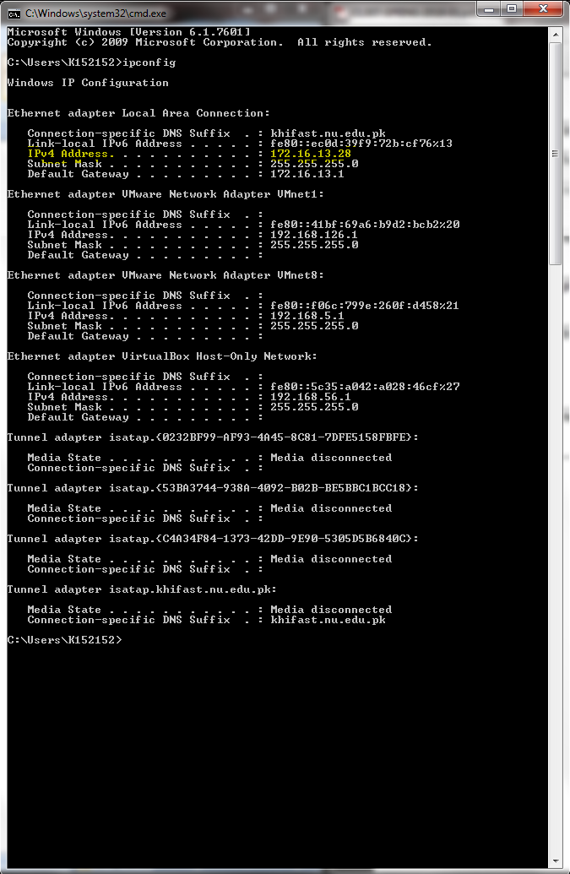Q1

Command: ipconfig

Q2

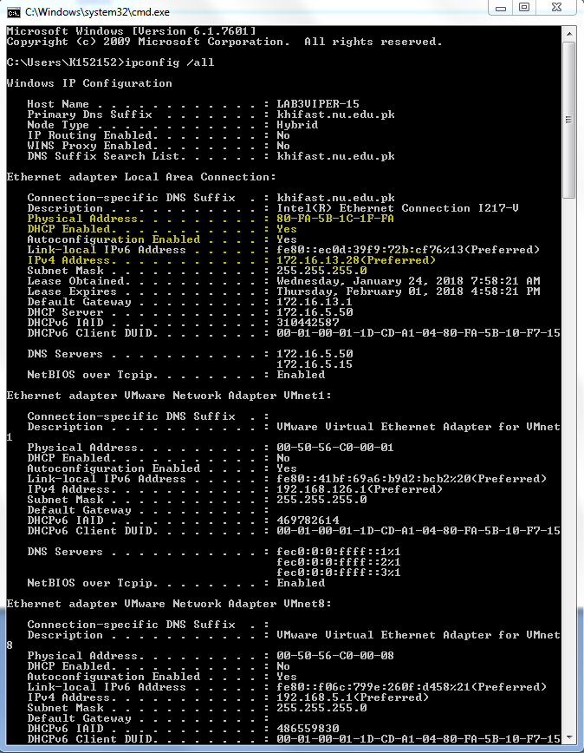

Command: ipconfig /all

Q3

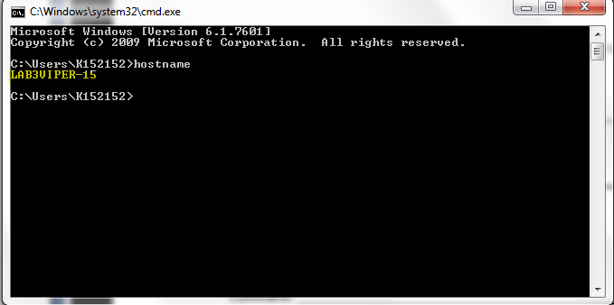

Command: hostname

Q4

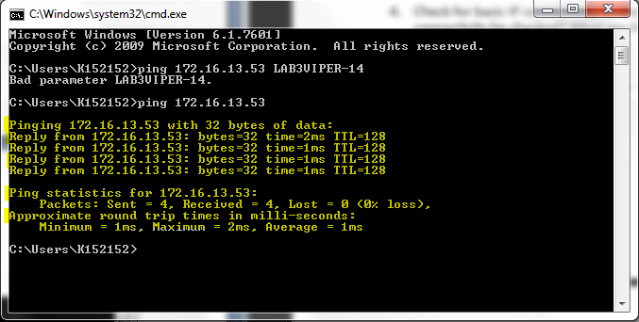

Command: ping 172.16.13.53

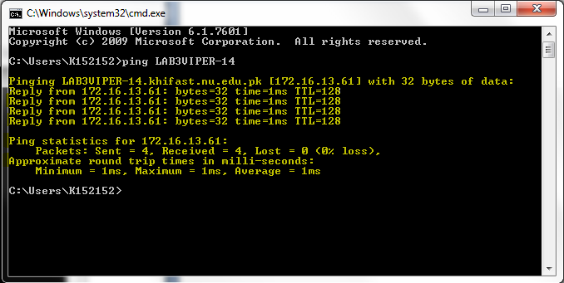

Command: ping LAB3VIPER-14

Q5

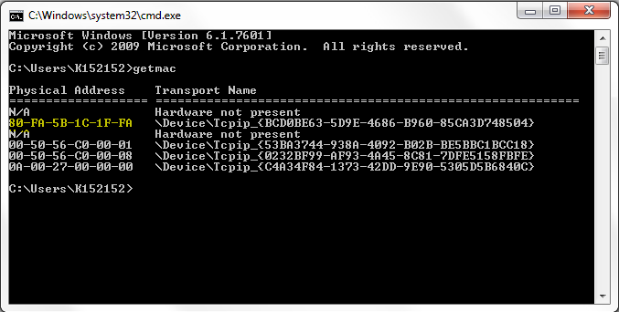

Command:getmac

Q6

Hostname:K152152

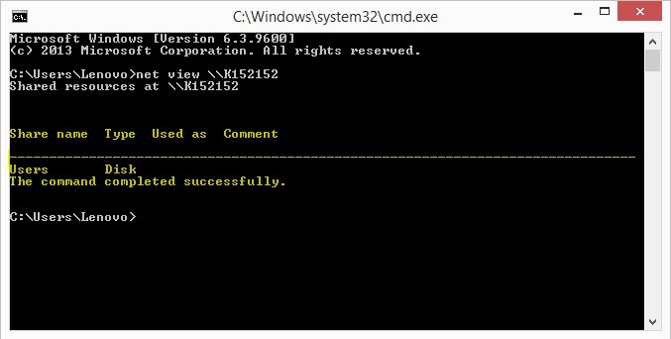

Command: net view \\K152152

Q7

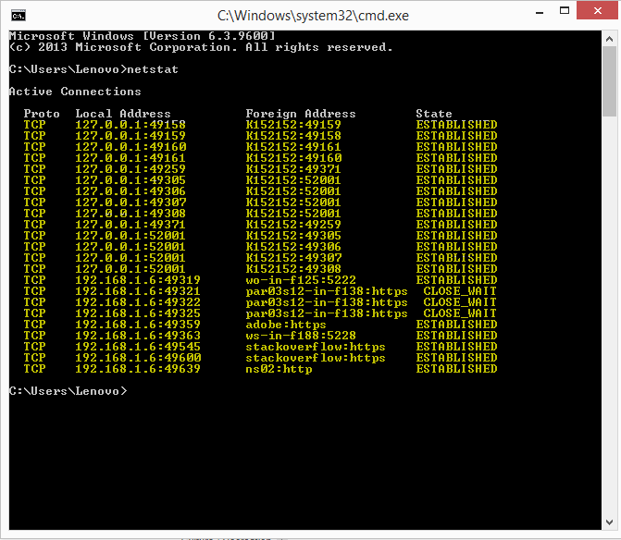

Command: netstat

Q8

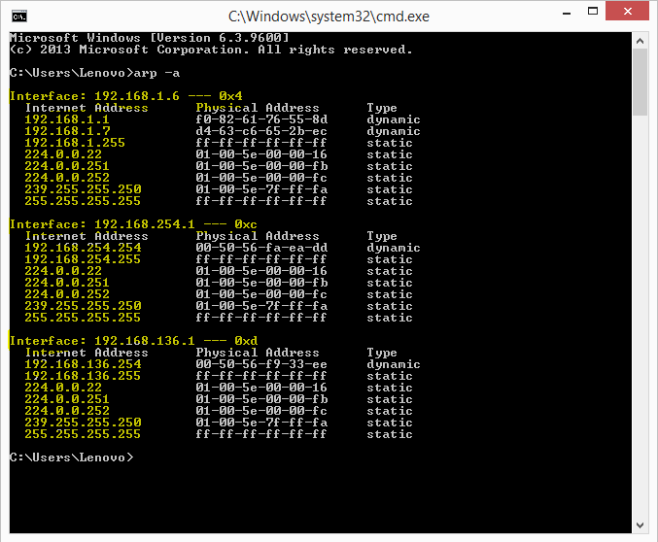

Command: arp –a

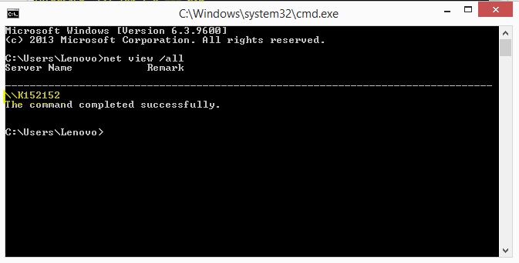

Command: net view /all

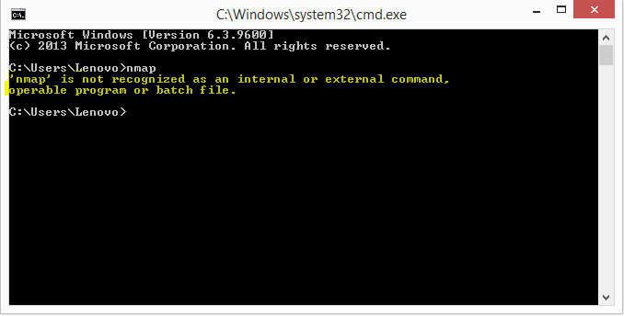

Command: nmap

Q9

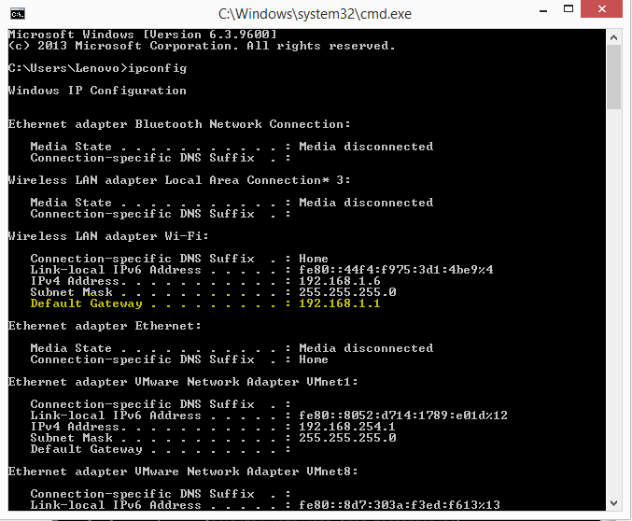

Command: ipconfig

Q10

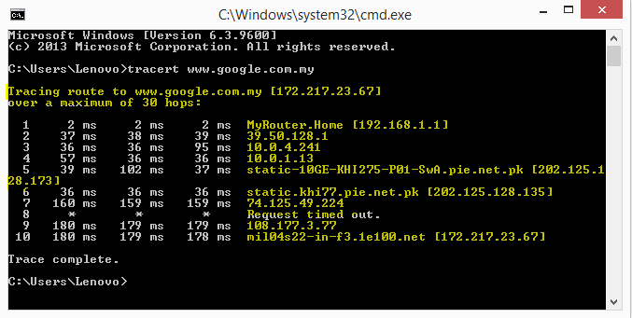

Command: tracert [www.google.com.my](http://www.google.com.my)

Q11

The problem is with the DNS server. The network only knows IP addresses, not the names. Si ping with IP will work without any name service, but with hostnames only when there is a way to convert hostnames to IPs, hence there is problem with DNS server.